figures
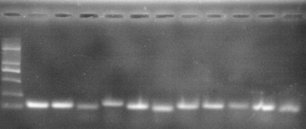
100
250
500
M
2
1
3
11
4
10
5
9
8
6
7
bp

Figure S1. The agrose gel electrophoresis of the eleven candidate reference genes. M,DL 2000 bp Marker; Templates in the PCR reactions were as follows: 1) 18S; 2) 28S; 3) Actin; 4) ATPase; 5) EF1A; 6) HSP60; 7) HSP70; 8) HSP90; 9) NADH; 10) RPL32; 11) Tubulin.

