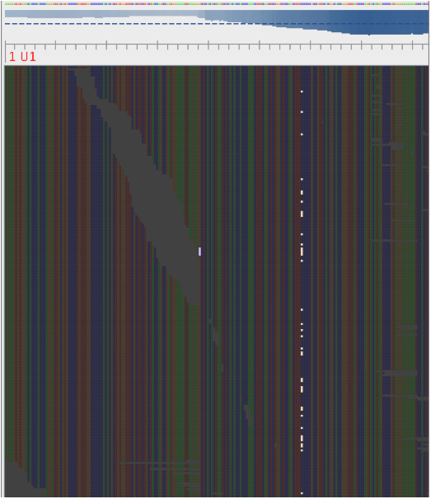
Supplementary Figure 1: Mixed position in an stx2a gene. Variant from reference highlighted.
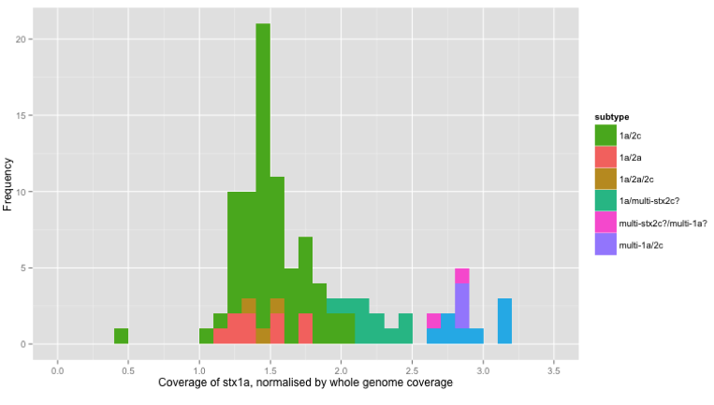
Supplementary Figure 2: Histogram of coverage of stx1a normalised by whole genome coverage

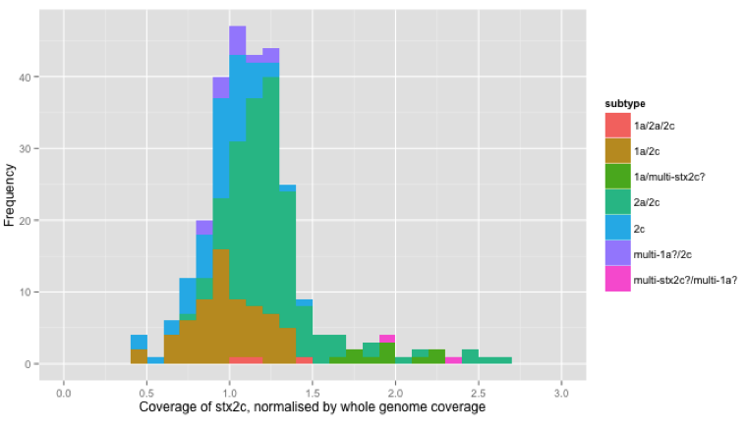
Supplementary Figure 3: Histogram of coverage of stx1a normalised by whole genome coverage
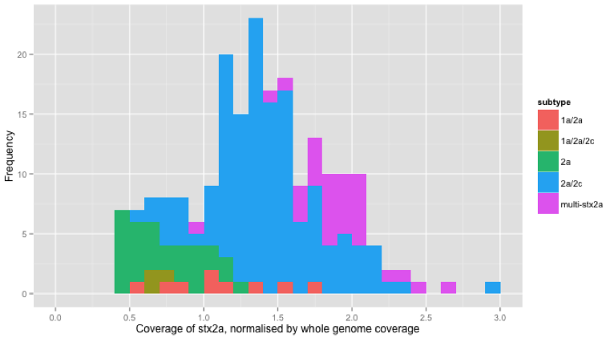
Supplementary Figure 4: Histogram of coverage of stx1a normalised by whole genome coverage

