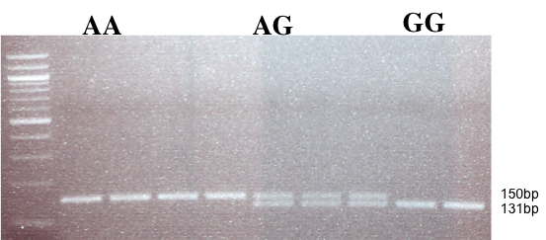

Supplement 1. Gel electrophoresis of CD209 gene promoter (SNP -336 A/G; rs4804803). Amplified PCR products were digested with MscI restriction endonuclease (New England Biolabs), and expressed on an ethidium bromide stained 2% (w/v) agarose gel. Wild type variant (snp-336AA) showed no digestion (150 bp), while mutant variant (snp-336GG) produced two bands (131 and 19 bp) on digestion. Lower band size not seen; Marker: 100 bp TriDye DNA ladder (New England Biolabs)

