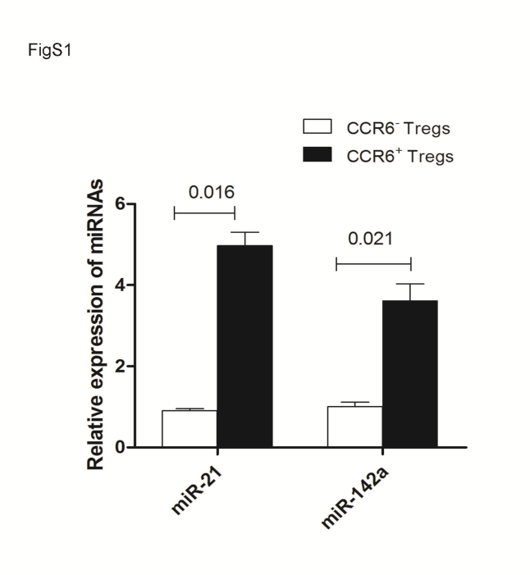

Figure S1. The relative expression of miR-142 and miR-21 in CCR6⁺Tregs.
CCR6⁺Tregs and CCR6⁻Tregs were purified from splenocytes in Balb/c mice by FACS sorting. The relative expression of miR-142 and miR-21 in CCR6⁺Tregs cells was determined by Realtime PCR assay.

