Supplementary File 4: Aperture ontogeny profiles for 11 Plectostoma species, which each was label by respectively shell shape (see also Figure 3 & Figure 4 in the main manuscript).

Figure S1. Aperture ontogeny profiles which are labelled by the apex shape of the shell. (A) Aperture size; (B) Aperture shape; (C) Standardised torsion; (D) Standardised curvature; and (E) Standardised torsion same as (C) but focus on a particular portion of standardised ontogeny axis.
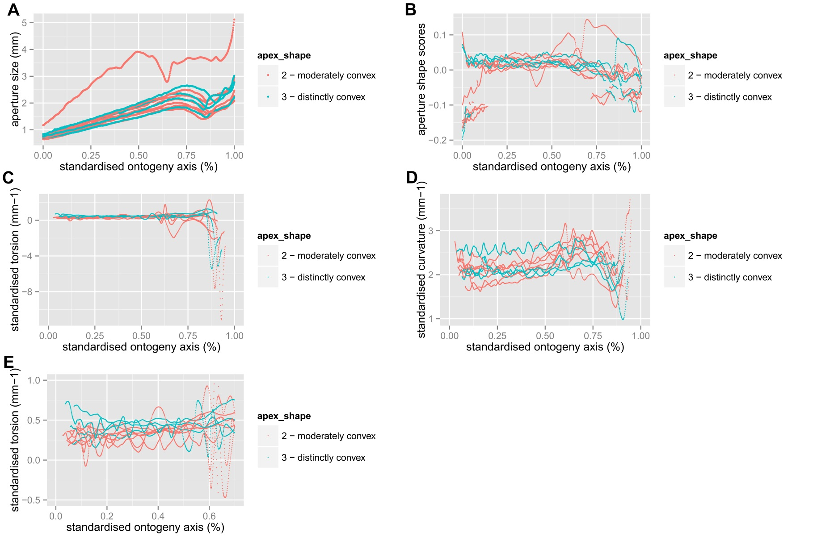
Figure S2. Aperture ontogeny profiles which are labelled by the apical spire shape of the shell. (A) Aperture size; (B) Aperture shape; (C) Standardised torsion; (D) Standardised curvature; and (E) Standardised torsion same as (C) but focus on a particular portion of standardised ontogeny axis.
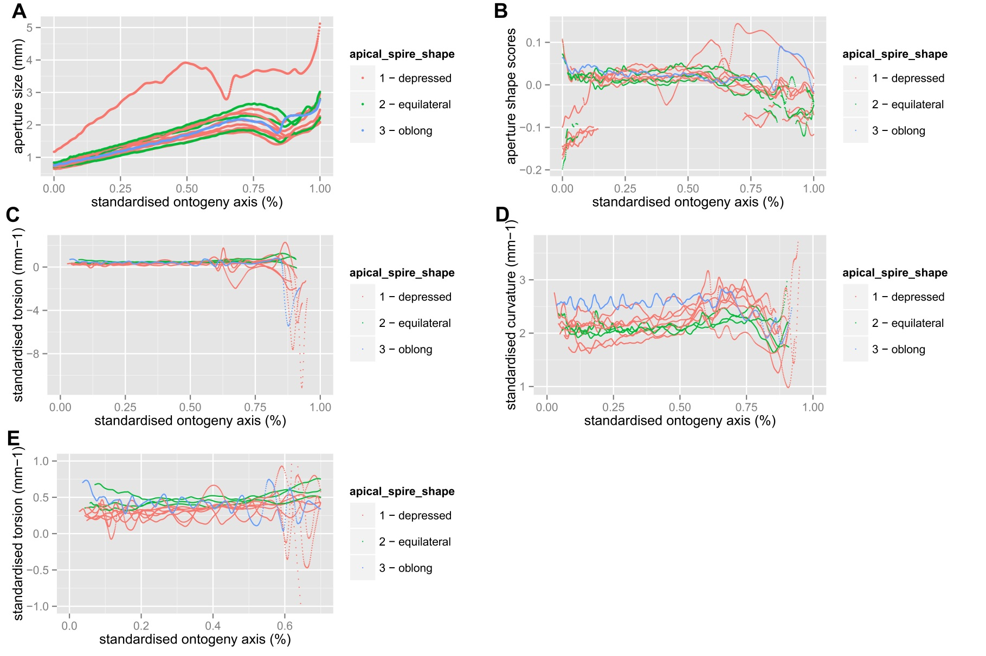
Figure S3. Aperture ontogeny profiles which are labelled by the basal spire shape of the shell. (A) Aperture size; (B) Aperture shape; (C) Standardised torsion; (D) Standardised curvature; and (E) Standardised torsion same as (C) but focus on a particular portion of standardised ontogeny axis.
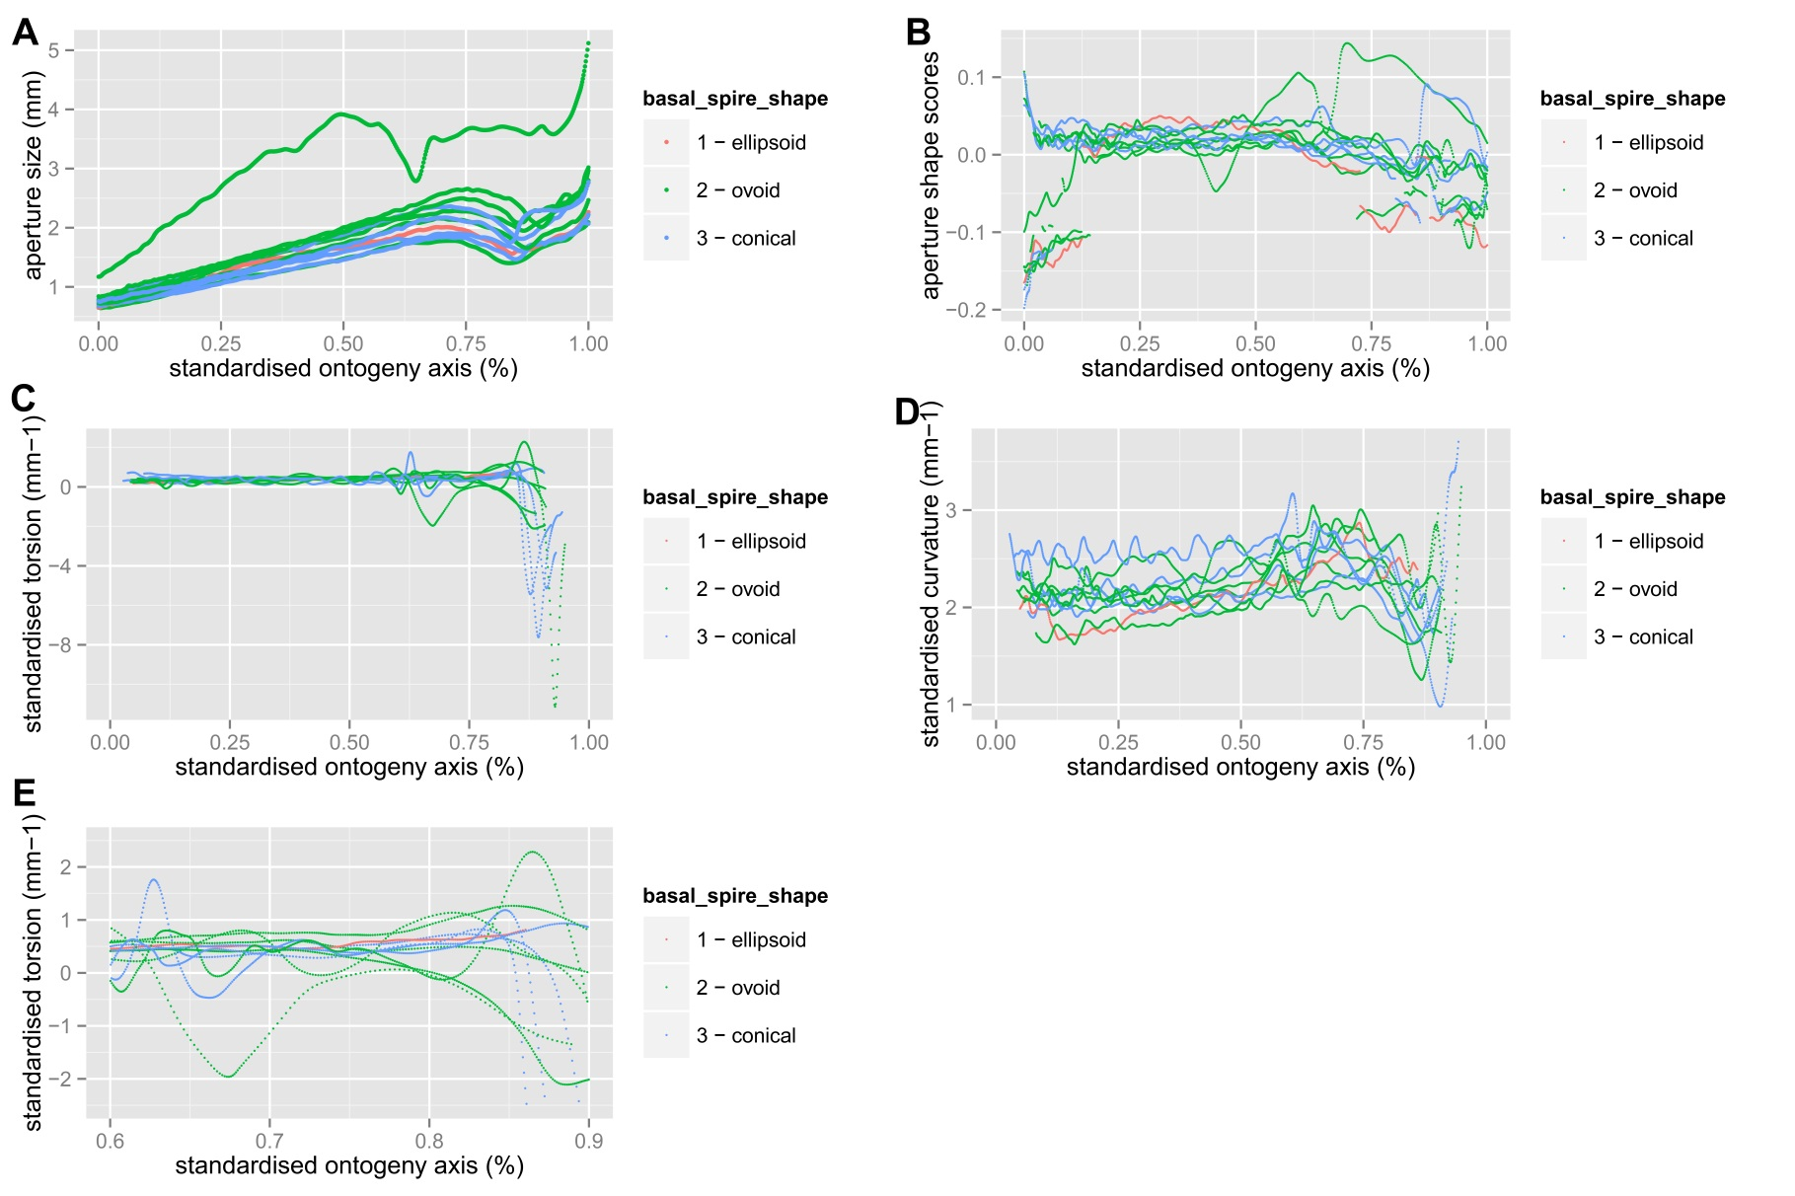
Figure S4. Aperture ontogeny profiles which are labelled by the tuba coiling types of the shell. (A) Aperture size; (B) Aperture shape; (C) Standardised torsion; (D) Standardised curvature; and (E) Standardised torsion same as (C) but focus on a particular portion of standardised ontogeny axis.
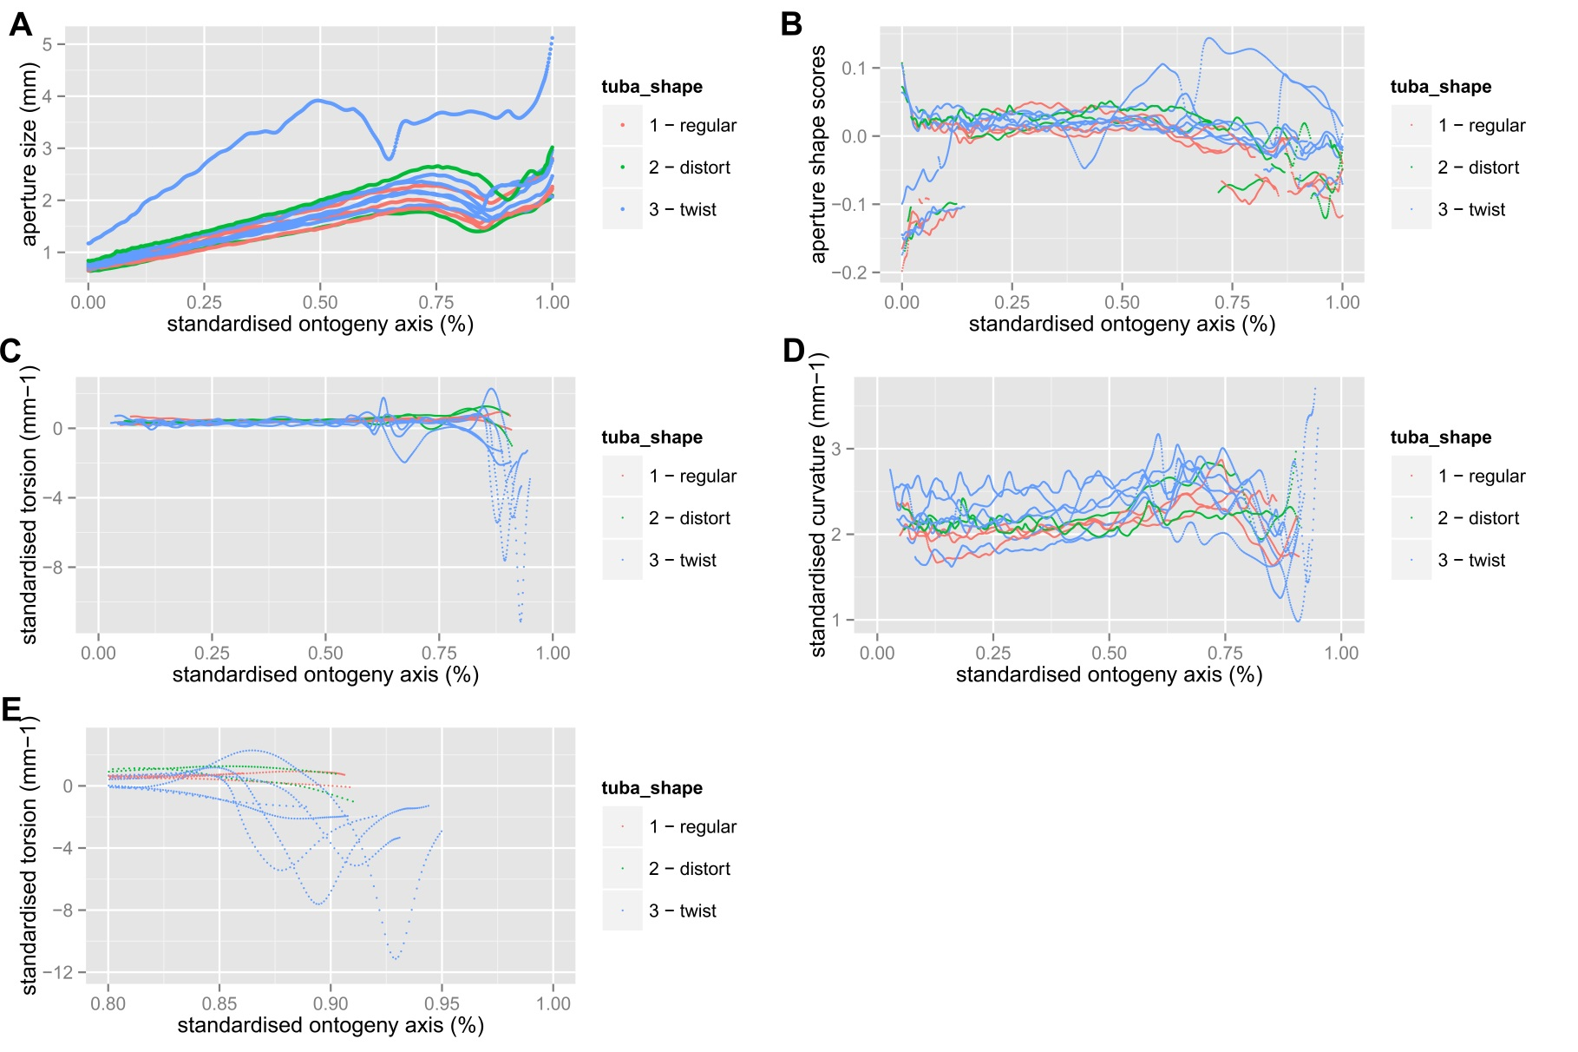
Figure S5. Aperture ontogeny profiles which are labelled by the aperture view of the shell. (A) Aperture size; (B) Aperture shape; (C) Standardised torsion; (D) Standardised curvature; and (E) Standardised torsion same as (C) but focus on a particular portion of standardised ontogeny axis.
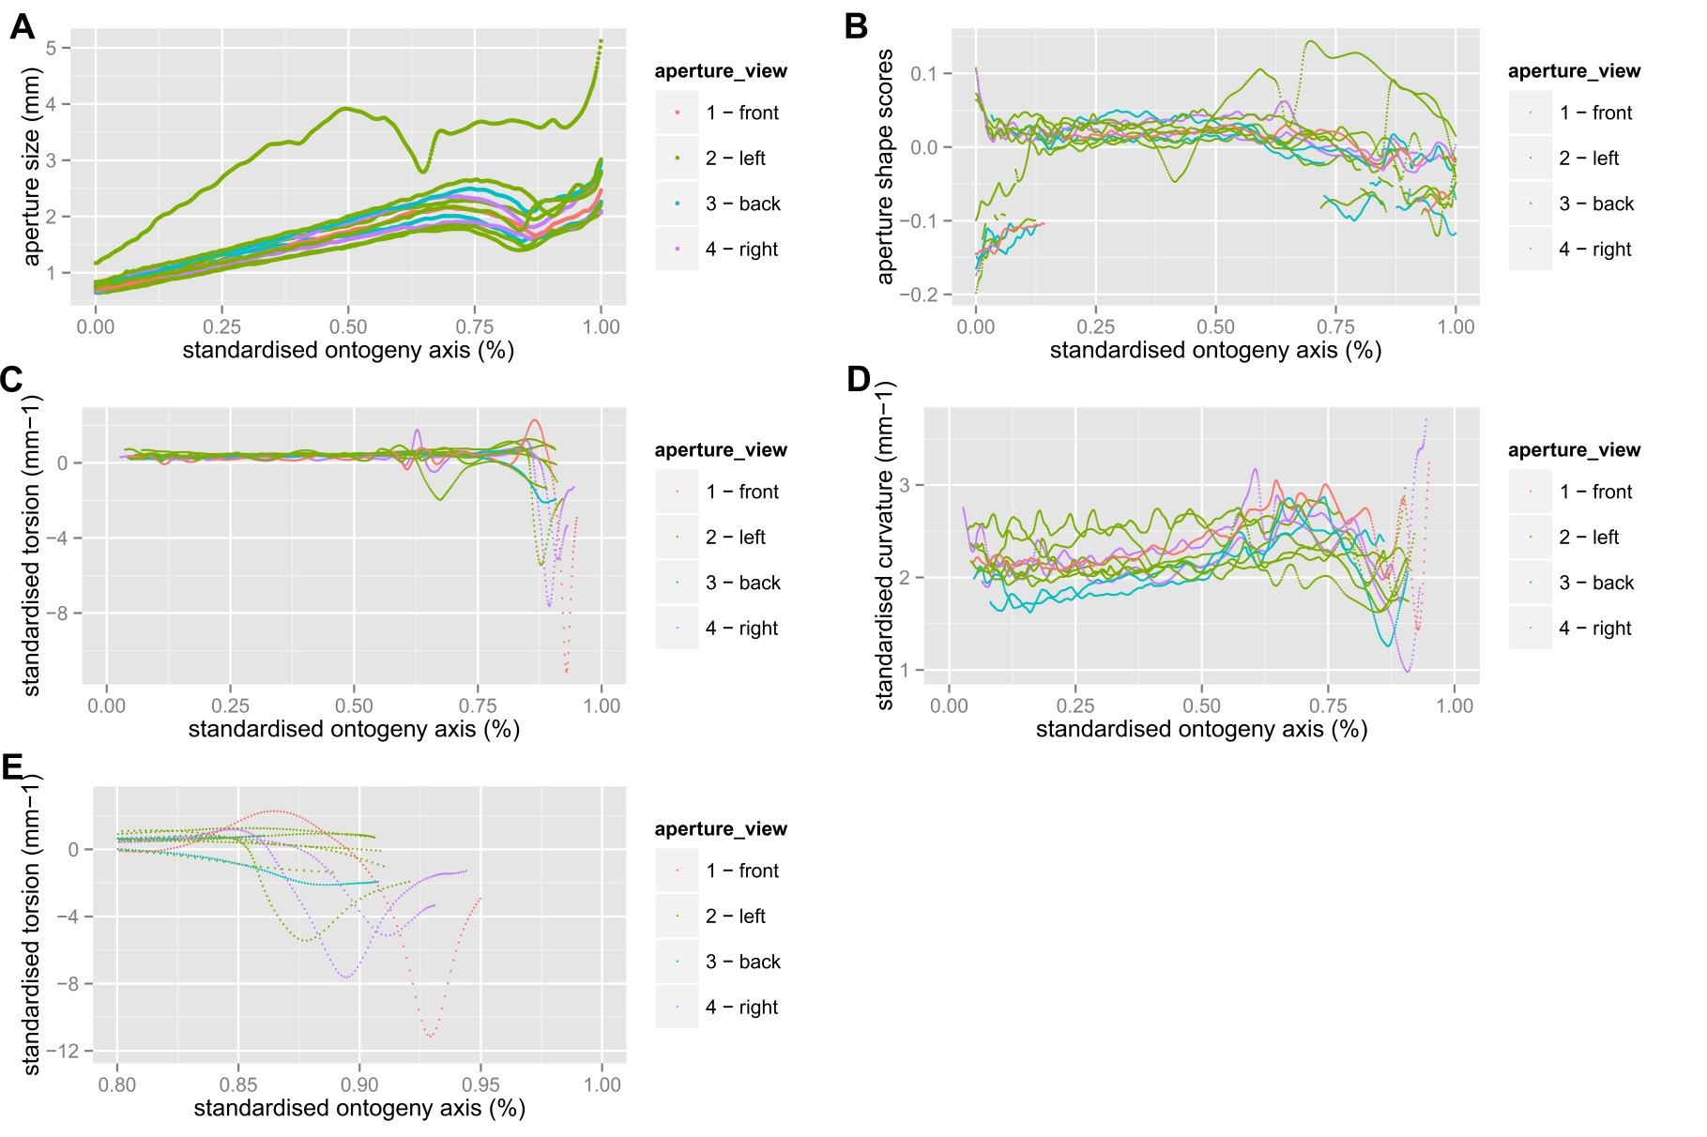
Figure S6. Shell ontogenetic morphospace of the 11 Plectostoma species after excluded the outlier region (see Figure 4). Occupancy of each of the four shell shape characters in standardised curvature and aperture shape dimension of the ontogenetic morphospace (see also Figure 5B). 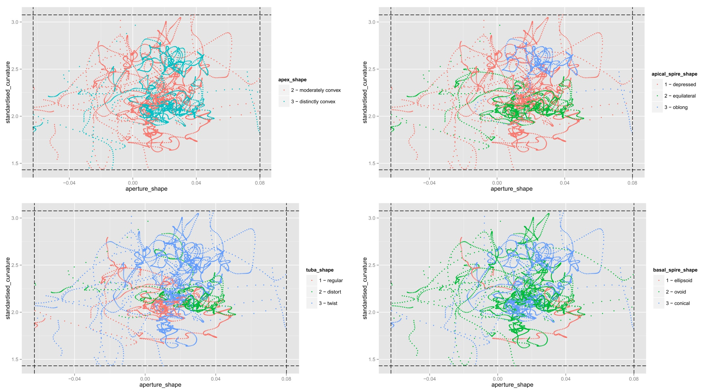
Figure S7. Shell ontogenetic morphospace of the 11 Plectostoma species after excluded the outlier region (see Figure 4). Occupancy of each of the four shell shape characters in aperture shape and standardised torsion dimension of the ontogenetic morphospace (see also Figure 5C). 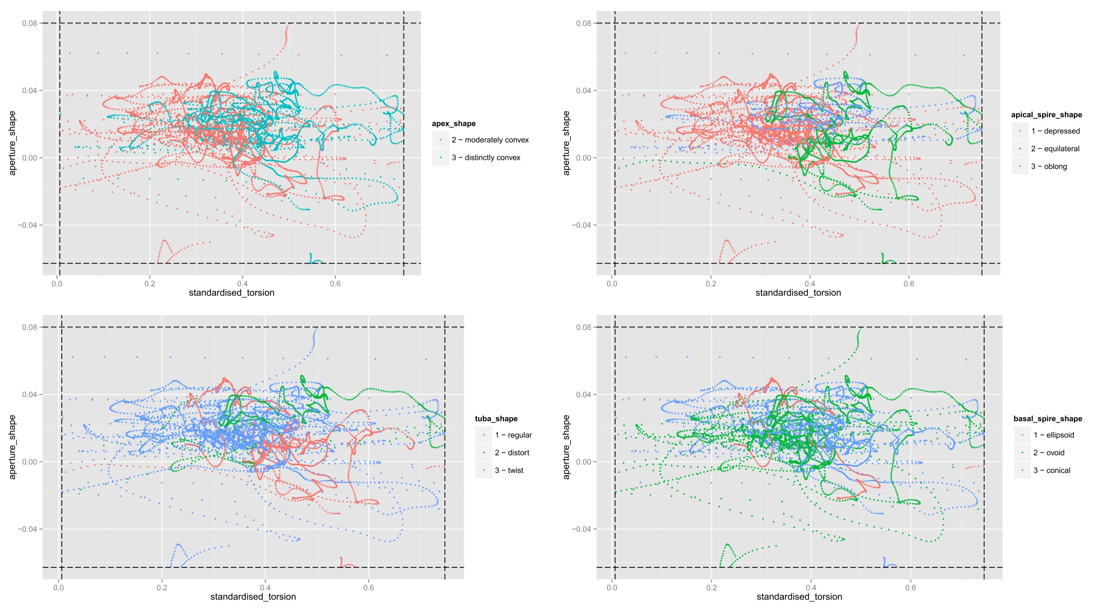
Figure S8. Shell ontogenetic morphospace of the 11 Plectostoma species after excluded the outlier region (see Figure 4). Occupancy of each of the four shell shape characters in standardised curvature and standardised torsion dimension of the ontogenetic morphospace (see also Figure 5A).
