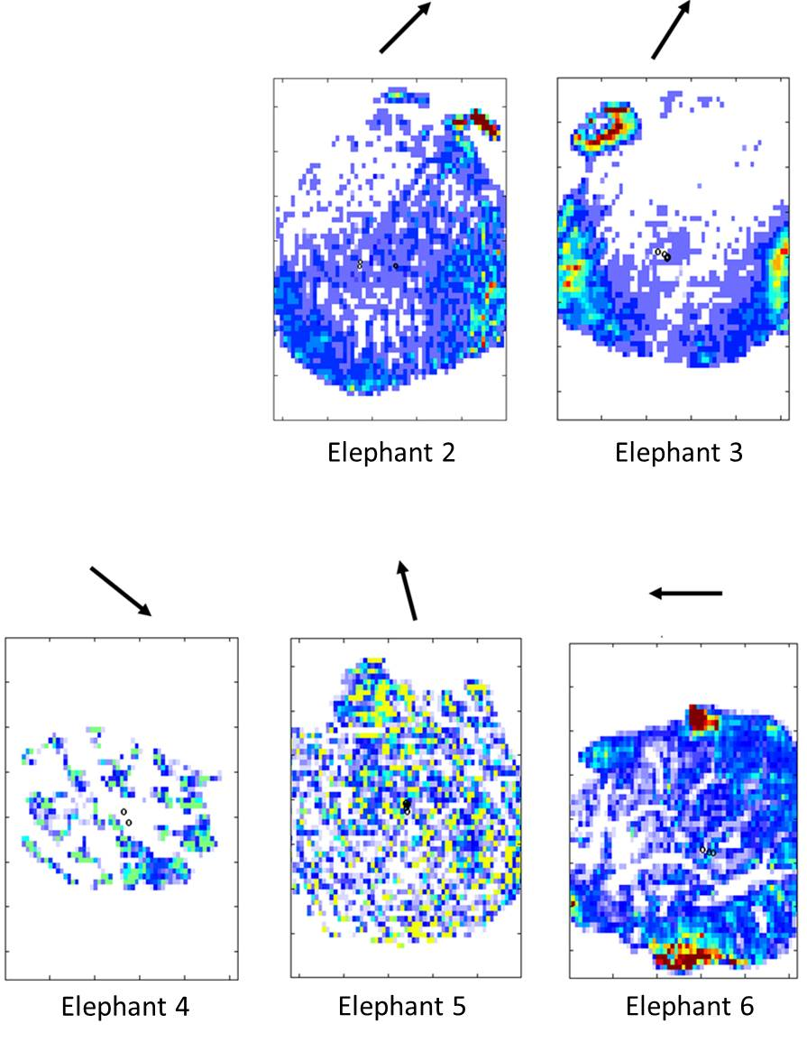
Supplementary figure S8 Centre of pressure (CoP, black circles) in each elephant foot, across all trials. Arrows indicate the orientation of the 3rd digit. Data for Elephant 1 are missing due to technical difficulties with the pressure pad (see Data S6 for details). Warm colours denote higher pressures, whereas cool colours denote lower pressures, white areas show zero pressure. The purpose here was to show the CoP in relation to the foot, rather than pressure magnitudes. Note the variation in contact area between individuals, which is likely to vary due to toe nail length, and the presence of fissures in the sole (dependant on abrasion/foot trimming).

