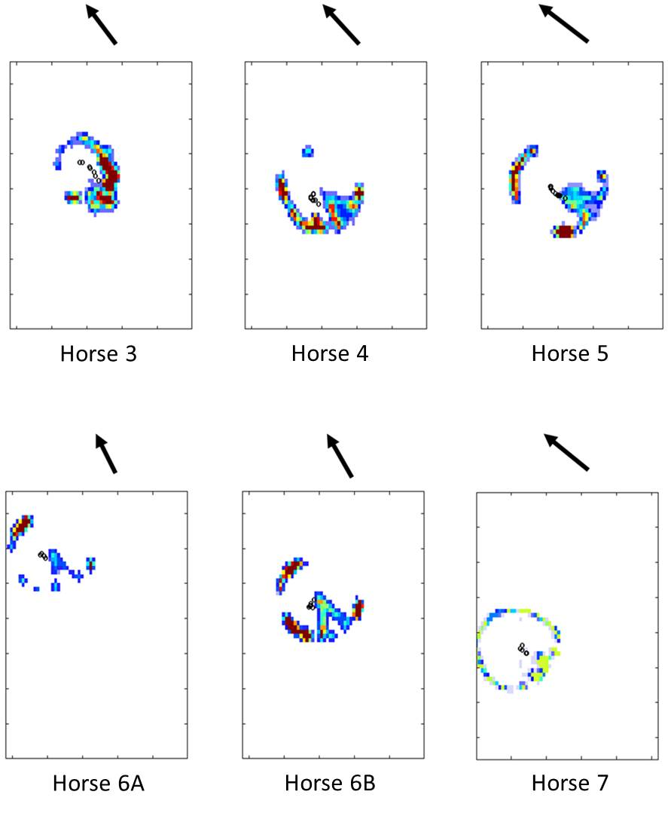
Supplementary figure S7 Centre of pressure (CoP, black circles) in each horse foot, across all trials. Arrows indicate the orientation of the hoof. Data for Horse 1 and 2 are missing due to technical difficulties with the pressure pad (see Data S6 for details). Warm colours denote higher pressures, whereas cool colours denote lower pressures, white areas show zero pressure. The purpose here was to show the CoP in relation to the hoof, rather than pressure magnitudes. Note the limited contact area of the foot, which is highly variable and likely to depend on hoof balance/trimming and concavity of the sole.

