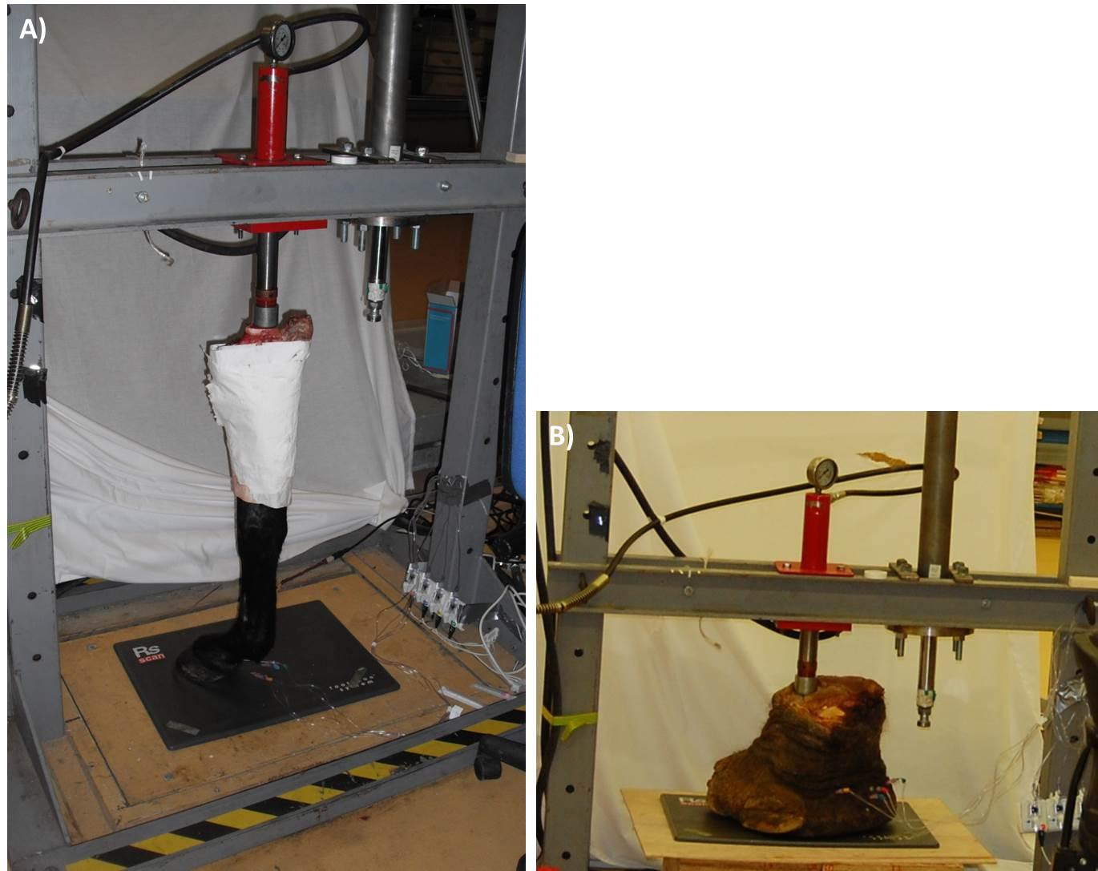
Supplementary figure S6: Experimental set up. A) horse forelimb, B) elephant forelimb.

