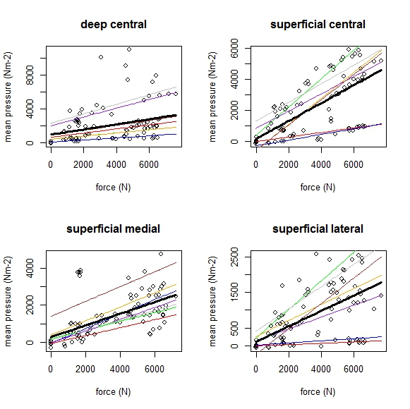

**Supplementary figure S4 Horses: Individual variation in mean internal pressure by region.** Coloured lines show individuals, black line shows fitted LMM used for analysis.