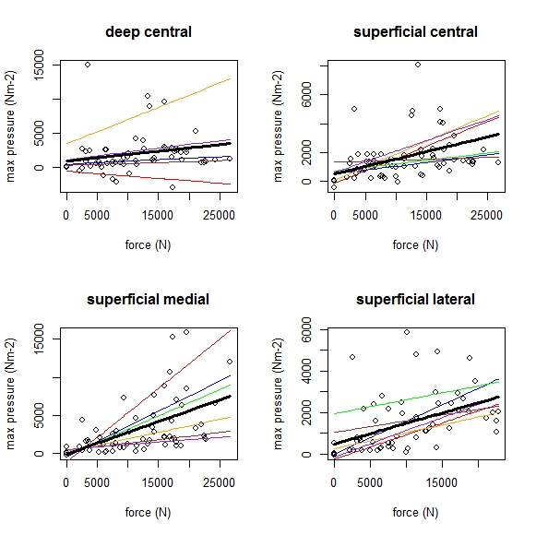

**Supplementary figure S3 Elephants: Individual variation in maximum instantaneous internal pressure by region.** Coloured lines show individuals, black line shows fitted LMM used for analysis. Despite pathologies being present in some elephant limbs, the models for each individual follow a similar pattern, hence excluding pathological limbs from the analysis was not deemed necessary.