Supplementary data S9: Technical issues with RS pressure mat
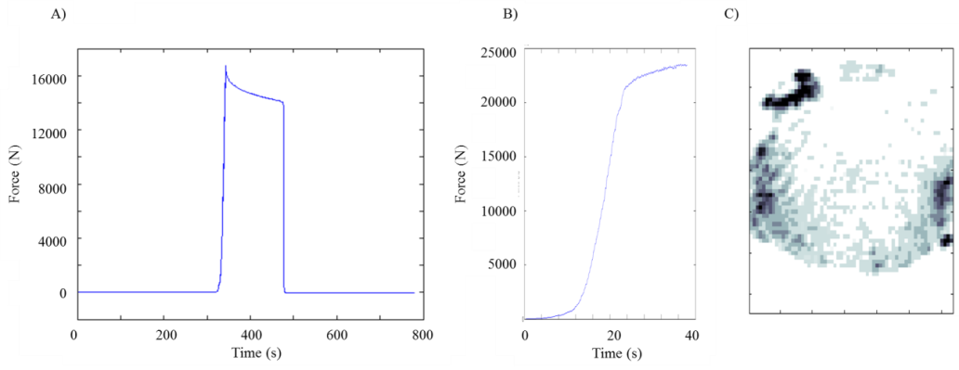
In addition to the RS software intermitently failing to record data (without any indication during collection), the pressure pad frequently showed an error in the the measured force. Figure S9.1 shows a successful trial (Elephant 3 trial 6), where despite the pressure pad overestimating force (B), the force trace (A) is as expected, showing the limb being load and unloaded according to the trial timings. Figure S9.2 shows the subsequent trial (Elephant 3 trial 7), where the pressure pad (B) recorded an erroneous force trace. Since the pad calculates external pressure utilising the force, all trials with this particular problem had to be omitted from the analysis, severly limiting the available data. When the pad was tested with known weights (~70kg) the force and pressures were deemed correct; the pad had been poorly maintained prior to use and was returned to the manufacturer for repair.
Supplementary figure 9.1 A successful trial with regards to external pressure (Elephant 3 trial 6). A) Kistler force data, B) RS force data, C) pressure calculated from the corrected RS force data. Note the pressure pad has overestimated force by ~ 10,000 N (+60%).

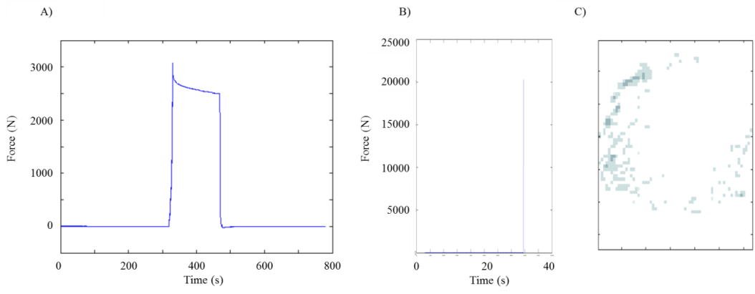
Supplementary figure S9. 2 An unsuccessful trial with regards to external pressure (Elephant 3 trial 7). A) Kistler force data, B) RS force data, C) pressure calculated from the RS force data. Note that the pressure pad has erroneous force and subsequently the calculated pressure is incorrect.

